# Onlyfans Analytics

* This chapter will explain how to read and understand the Onlyfans analytics part of the Tracking Sheet
* First, you gather the Getallmylinks link clicks. On your front page, you have a nice graph, which shows you how many clicks you got per day.
  + This is the most consistent tracker of clicks. The tracking in IG analytics or tracking on OF is highly unreliable.
* Second, you gather the Onlyfans New Subscriber numbers.
  + Go to the Statistics Tab
  + In the top bar, select “Fans”
  + Select to show only “New Subscribers”
  + By hovering over the graph, you can see the number of subscribers for any date.
  + Generally, you’ll be filling this out daily, thus checking the previous day’s numbers.
  + 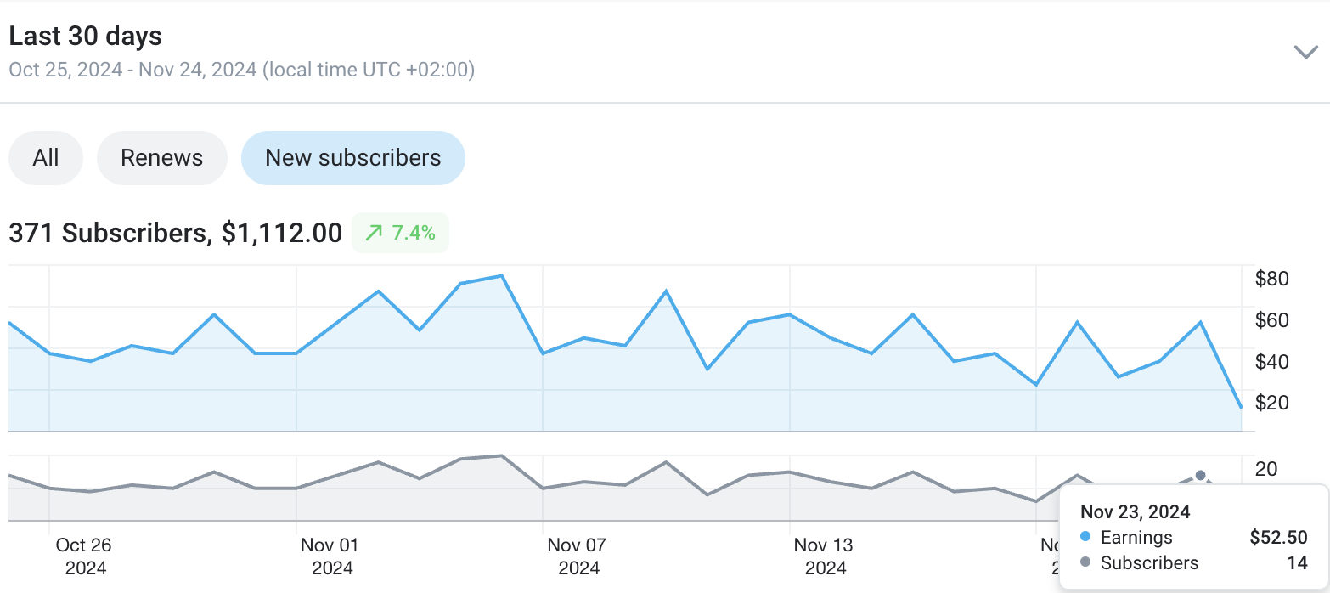
* Once you fill in both the numbers, the Conversion Rate column will automatically calculate the conversion rate.
  + Generally guidelines:
  + Below 1% - Bad Conversion Rate
  + Between 1-2% - Mediocre Conversion Rate
  + Between 2-3% - Good Conversion Rate
  + Above 3% - Excellent Conversion Rate
* What affects conversion rate:
  + Funnel setup: is your funnel setup as cleanly and well as described in the “Setting up your funnel” Chapter?
  + Social Media Content Mix: If your content is too “Slutty”, it might not actually convert the best. If you content is too “Safe” it might not also convert.
    - Generally we suggest a 50/50 mix of Sexy and Classy/Funny/Edited etc… content
    - Intrigue people more than just by being sexy
  + Audience Mix: Generally US subscribers convert the most. For example, a country like Romania might convert a lot less.

## Frequently Asked Questions

* **When should I be happy with my conversion rate?**
  + Generally, if your conversion rate is above 2%, that is good, you don’t have to worry about conversions daily.
  + Raising it above 2% will then often take controlled tests, as covered in previous chapters. You will want to test things out for 30 days, to see what can raise your conversion the most.
  + If your conversion is above 3%, that is already amazing, and you really don’t have to worry about it.
    - Of course, continued tests, might in time bring you even higher. Though most often that easiest leverage, as discussed in the funnels chapter, will be increasing views.
* **What if my conversion rate is below 2%?**
  + Most often the first fix will be your funnel. Likely it is not implemented cleanly and people are disappearing somewhere.
  + If that isn’t the case, either your content is way too sexy, leaving no reason for people to subscribe. Or it’s so safe guys don’t even get excited.
  + Ask about this on a call, how this can be improved further.
  + Anything below 2% is generally leaving a lot of money on the table.
    - Some fixes might be quick - like a funnel
    - Content mix fixes might take a series of 30 day test
  + You will only know if you track your data well. And you must note exactly what you changed, otherwise you will never know what worked and what didn’t.